Strategic and Twitch Skill – Online Diary.

3.0 Game Premise

Our game, called Smash Explosion, is a strategy game, where players work together in a team to attempt to diffuse a bomb, within a given time limit. This twist is that only one person in the team can look at the bomb, and the rest of the team must use the Bomb Defusal Manual to try and assist the bomb diffuser.

3.1 Materials

Photoshop was used to create the Maze module. Paint was used to create the bombs and the Wires module. A word document table was used to create the Emoji Keys module. The emojis used were taken from the website https://getemoji.com/

3.2 Rules and Mechanics

Players use a D6 die to decide which of the 6 different bombs they are going to attempt to diffuse. The number shown on the die indicates which bomb they receive. (See Fig. 7 for image of a ‘Bomb’)

Only one member of the team can look at the bomb. The other team members look at the Bomb Defusal Manual. The bomb defusal manual has information on the 3 different modules that must be diffused in order to successfully disarm the bomb. All 3 modules must be completed.

The team must set a timer of 3 minutes when the game starts. This is the time they have in order to diffuse the bomb.

If any rules are broken by the players of bomb diffuser, the bomb will explode instantly, thus ending the game.

3.2.1 Maze Rules

Each Maze module will have green circles on it. These circles correspond with the same maze within the Bomb Defusal Manual (BDM). Within the BDM is the solution to the maze. The Diffuser must correctly convey the position of these green circles in order to find the right maze, so that other team members can guide them.

Assistants must help guide the Diffuser, by giving directions. The aim of this module is to get the blue dot to the red dot, as shown on Fig. 1.

The diffuser cannot see the black lines, as shown in Fig. 2. If the diffuser crosses the black lines, the bomb explodes.

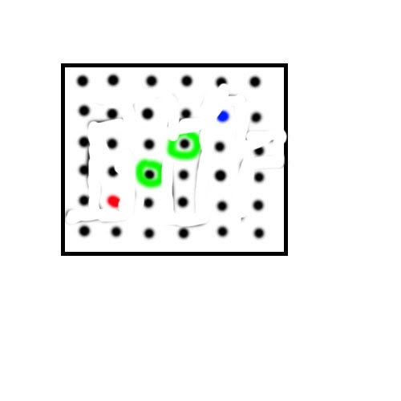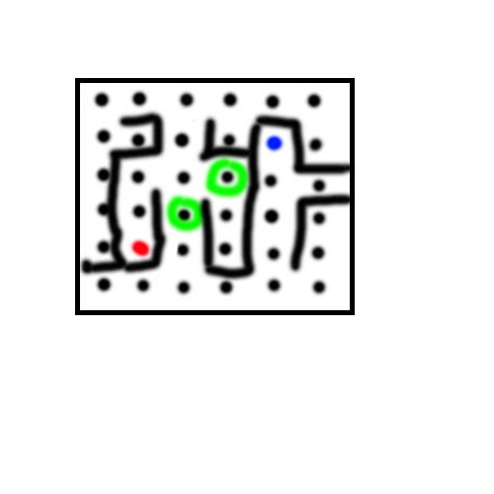

Figure 1. What the bomb diffuser sees

Figure 2. What the bomb assistants see

3.2.2 Wire Sequences Rules

The Assistants must help the diffuser cut one correct wire to diffuse this module.

Each Wire module has different wires but has the same layout as shown in Fig. 3. Players must work together to communicate and successfully identify which wire to cut.

Wires are ordered with the first wire at the top.

All possibilities and information about wires can be found on the BDM.

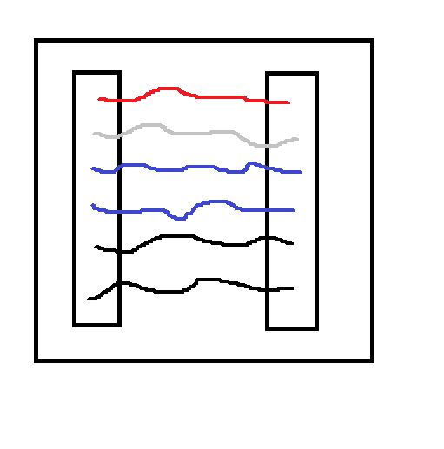

Figure 3. Example Wire Module

3.2.3 Emoji Keys

The Diffuser must tell the Assistants which 4 emoji’s they see on the module, as shown in Fig. 4.

Assistants then must find the correct column in the BDM (see Fig. 5) with all 4 emoji’s in it.

Once the correct column is found, the module is diffused.

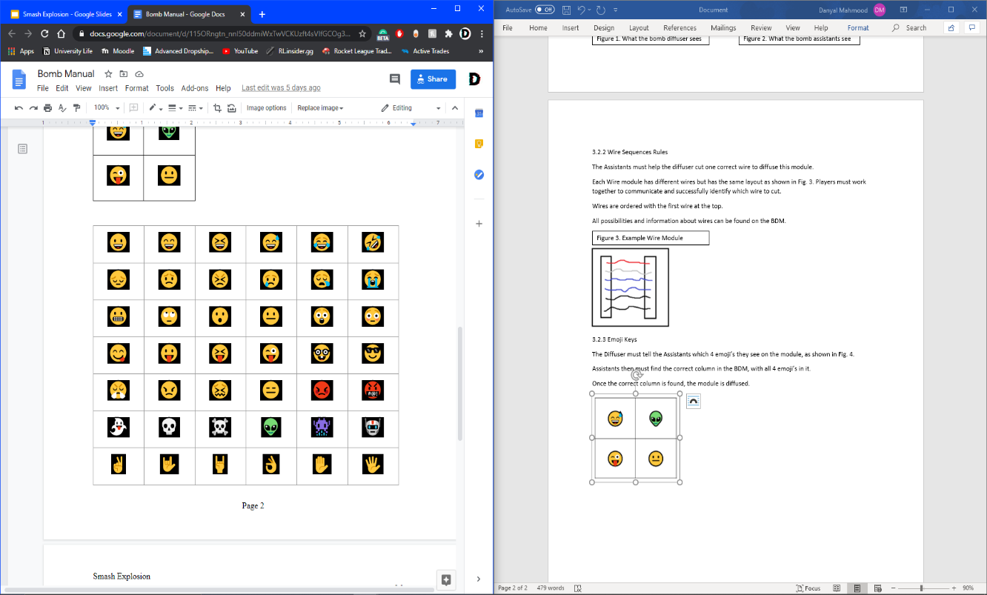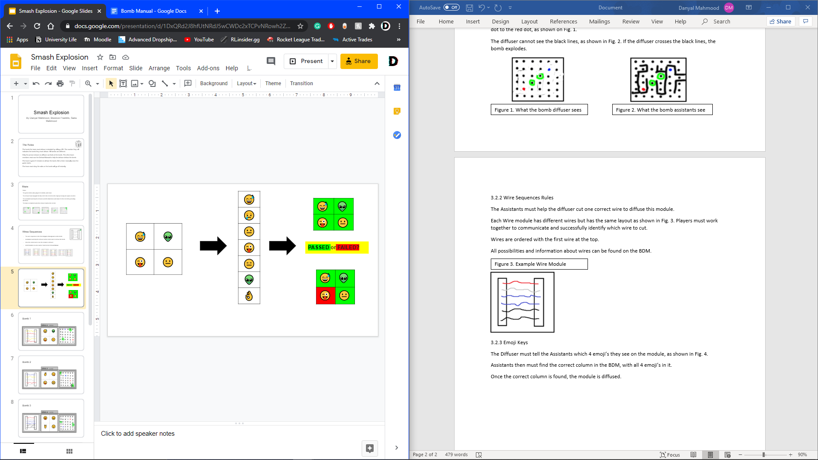

Figure 5. All columns found in the BDM

Figure 4. Exemplar Module

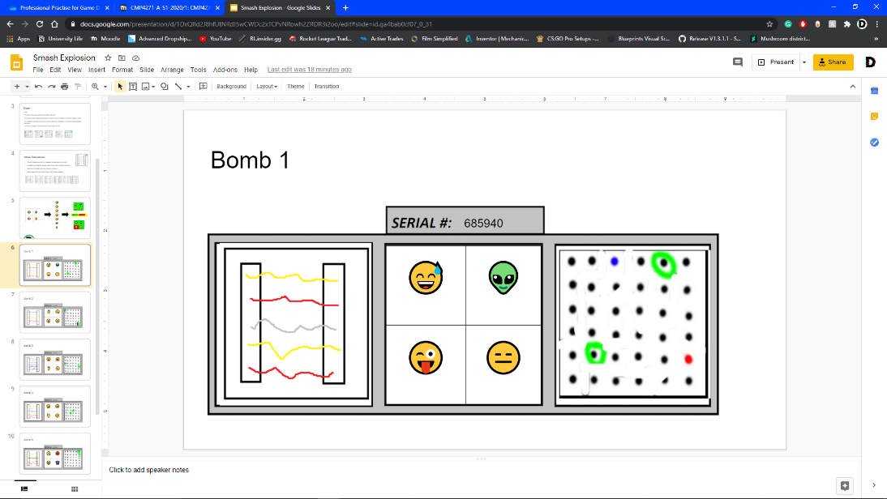

Figure 7. An Exemplar Bomb

3.3 What we found from Play testing.

When the game began, some of the artwork for the Maze module was incorrect. The black lines (Fig.2) were visible on the Module that was on the bomb. This was quickly corrected, with the lines removed. Originally the timer was 5 minutes, but we found that the game ends quite quickly as the modules are simple. As a result, we decreased the time limit to 1 minute per module – 3 minutes total. If we had done more external playtesting, we could have seen how quickly people picked up on learning the modules – especially new players. With this information, we could have decided to increase the number of modules on the bomb to make it more challenging for newer players that were finding the game too easy.

3.4 My experience of working in the team

Overall a good experience. This time each team member was delegated a specific module to work on, which increased efficiency and enabled us to do some basic playtesting. One team member had never used Photoshop before yet still managed to produce some good visuals for the bomb modules. The game was presented well and in a clear manner for new players to understand. For next time, I would have liked to create some 3D visuals to make the game more visually appealing.

3.5 Team Members

Brennon Franklin, Danyal Mahmood, Saira Mahmood.